SCANTLING OPTIMIZATION BASED ON

CONVEX LINEARIZATIONS
&
A DUAL APPROACH

Philippe RIGO (*) Claude FLEURY
Dept. of Naval Architecture (ANAST) Dept. of Aerospace (LTAS)

The OPTI model and the optimization algorithm.

The OPTI module is based on the CONLIN code developed by C. Fleury using a convex linearization of the constraints and the objective function combined in a dual approach.

With this algorithm, large constrained problems with implicit and non-linear constraints can be easily solved (Fig. 2). The main difficulty in solving a dual problem is dealing with the non-linear and implicit constraints.

In order to avoid a large number of time-consuming re-assessments of these non-linear and implicit functions, Fleury suggests applying convex approximations.

At each iteration all the functions (objective function and constraints) are replaced by an approximation called “convex”. In a word, the complex initial optimization problem is decomposed in a sequence of more simple convex optimization problems (obtained through a convex linearization) that can be easily solved using a dual approach (Fig. 2).

In order to consider non-linear implicit constraints (C(X_{i})), Fleury proposes replacing these constraints with approximated explicit linear constraints by using convex linearization.

He suggests using the first term of the Taylor Series Expansion.

Several alternatives are possible.

Three classic linear alternatives (*) are:

• Linearization with standard design variables (X_{i} , i=1,N) :

(1)

• Linearization with reciprocal design variables (1/X_{i} , i=1,N) :

(2)

• Convex linearization with mixed variables (X_{k} , k=1,L) and (1/X_{j} , j=L+1,N)

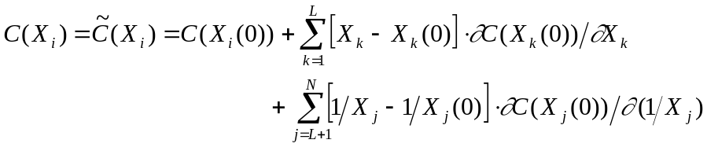 (3)

(*) Some other approximations exist.

As design variables refer to dimensions such as plate thickness, web height, etc., it is not suitable to use X_{i} to linearize constraints related to stress, strength and displacement. It is better to use reciprocal linearization (1/X_{i}). On the other hand, geometrical constraints (for instance: “w - h ≤ 0”, with h, the web height and w, the flange width) must be linearized with standard design variables (X_{i}) instead of reciprocal ones (1/X_{i}).

Therefore, for a general case, it is obvious that mixed linearization is the better way. But the problem remains how to determine which linearization is the most suitable (reciprocal variable 1/X or direct variable X) for each design variable.

C. Fleury has responded to this, proposing to make this selection in a way that replaces the actual design space (feasible domain for the design variables) by a smaller domain, included in the actual one, but convex.

One can summarise in this way: since the substitution design space is conservative, this leads to a solution that is still admissible, but that could be "slightly" different from the real optimum. Step by step, this conservatism is released as one comes closer to the real optimum.

The convexity of the design space and conservatism allow a safe and fast convergence.

The convergence is safe because, at each iteration, the updated solution has a tendency to still remain in the feasible domain.

Fleury has demonstrated that an efficient convex linearization can be achieved by selecting the group of variables (X_{i}) and the group of reciprocal variables (1/X_{i}) according to the sign of the first derivative of the function to linearize, that is ∂C(X_{i}(0))/∂X_{i}.

For a given design variable X_{i} :
- a linearization with standard variable X_{i} is achieved
if ∂C(X_{i}(0))/∂X_{i} > 0 ;
- a linearization with reciprocal variable 1/X_{i} is performed
if ∂C(X_{i}(0))/∂X_{i} < 0.

Therefore Eq.(3) becomes:

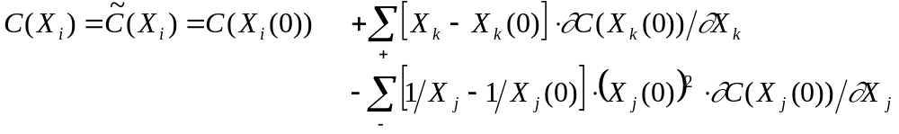 (4)
with ∂C(X_{k}(0))/∂X_{k} > 0 (1 ≤ k ≤ N) ;
∂C(X_{j}(0))/∂X_{j} < 0 (1 ≤ j ≤ N), for i=1,N

The proposed convex linearization is very "user friendly" as only the values of C(X_{l}(0)) and ∂C(X_{k}(0))/∂X_{k} are required.

The linearization is done automatically at each step (iteration) and the convergence order is 2.

In addition, the main advantage of the proposed convex linearization is the conservatism of the approximated function.

Let's note however that conservatism is only guaranteed with regards to initial linear functions in X_{k} and in 1/X_{j}. To avoid numerical problem the equations have to be normalised before starting the convex linearization. Fleury explains this procedure in [6-7].
As an example, consider the C1 and C2 constraints (Eq.(5a) and Eq.(5b)) and some feasible linearizations (Eq.(5c) to Eq.(5f)):

C1(X) = 5 X₂ - X₁² - 10 ≤ 0 (5a)

C2(X) = 5/4 X₂² + 16 / X₁² - 13 ≤ 0 (5b)

The considered initial point of the design variables is
X(0)=(X₁, X₂)=(2,2)

At this point, the two constraints and their first derivatives are the same as:
C1(2,2) = C2(2,2) = -4
∂C1(2,2)/∂X = ∂C2(2,2)/∂X = (-4,5).

Based on these equalities, all the linearized equations of C1 and C2 [Eq.(5c-5f)] are the same. According to the linearization models, Eqs.(1-4), we obtain for both C1 and C2:

• Standard linearization, X, Eq.(1): 5 X₂ - 4 X₁ - 6 ≤ 0 (5c)

• Reciprocal linearization, 1/X, Eq.(2): -20/X₂ + 16/X₁ - 2 ≤ 0 (5d)

• Convex linearization, Eq.(4): 5 X₂ + 16/X₁ - 22 ≤ 0 (5e)
The variables are: X₂ as ∂C/∂X₂ = 5 > 0
1/X₁ as ∂C/∂X₁ = -4 < 0

• Concave linearization, with X₁ and 1/X₂ 5 X₂ + 16/X₁ - 22 ≤ 0 (5f)

Fig. 3 shows that the convex linearization [Eq.(5e)], is the best one and the most conservative way, even if it fails with regards to C2, which is initially more convex (a quadratic function in X₂ and 1/X₁, Eq.(5b)) than the approximated convex function (a linear function in X₂ and 1/X₁, Eq.(5e)).

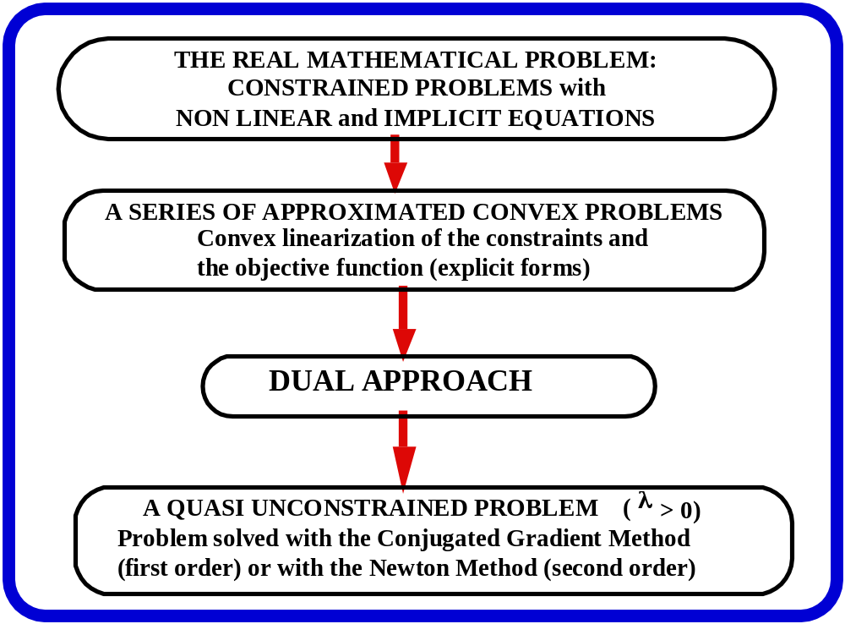

Fig. 2. The CONLIN model: convex approximations and dual approach.

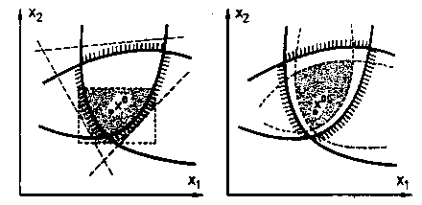

G(x)< 0 ; Original Design Space

G_{linearized}(x)< 0 ; Convex Approximation
X₁
X_{opt} (Convex Problem)
X_{opt}

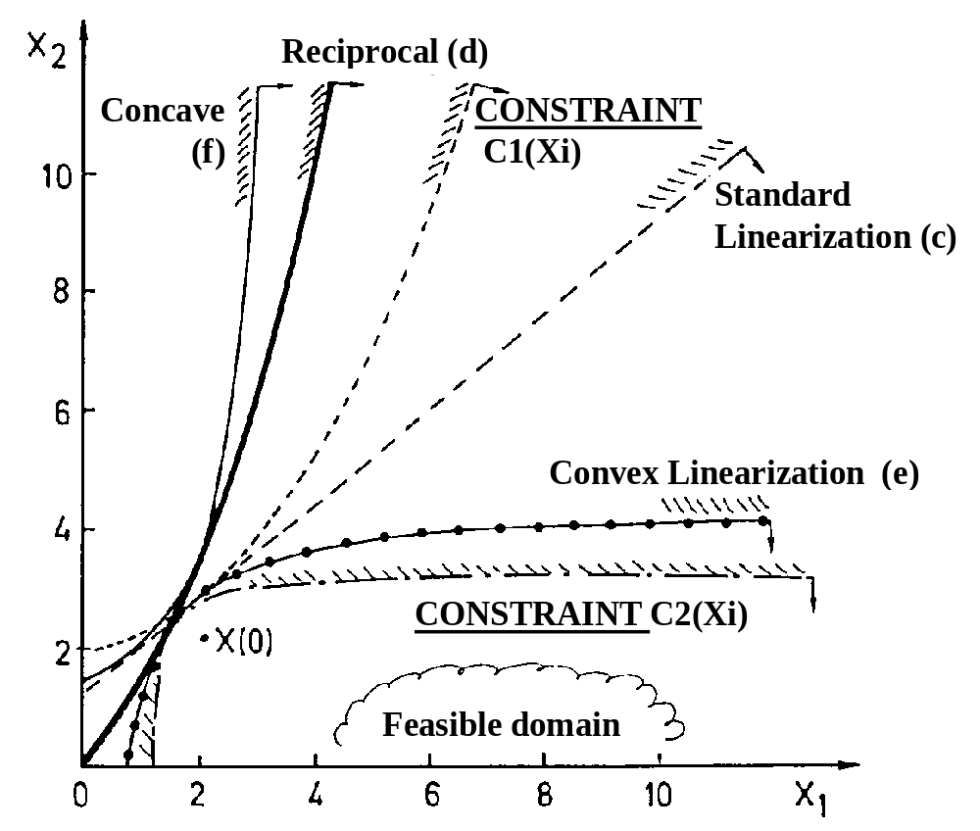

Fig. 3. Comparison between different linearizations.
A dual algorithm for optimization problem

- At each iteration, the normalised problem to solve is the following:

MIN [Σ F_{j} / X_{j} - Σ F_{i} . X_{i} ] with N design variables X

submitted to M constraint: Σ C_{j} / X_{j} - Σ C_{i} . X_{i} ≤ CM
and X_{i min} ≤ X_{i} ≤ X_{i max} the lower-upper bounds.

This problem is called a primal problem with reference to the X_{i} design variables, called primary or primal design variables.
It is a constrained problem with N design variables and M constraints.
This problem cannot be solved easily with classic methods such as, for example, the Conjugated Gradient.
A dual approach will be used here to replace the primal constrained problem with N unknowns by an unconstrained problem with M unknowns (called the dual problem).
This technique is especially advantageous when M << N.

- To the primal problem (convex with separable variables), one can associate the dual problem:

MAX(λ) [ Min(X) de L(X,λ) ] and X_{i min} ≤ X_{i} ≤ X_{i max}

with L(X,λ) the Lagrangien,
λ_{k} the M multipliers of Lagrange (dual variables)

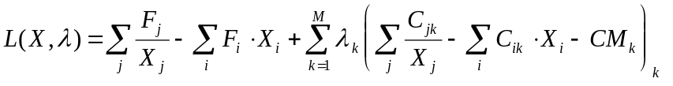 (6)
which is also a function with separable variables.

The dual problem is a QUASI-UNCONSTRAINED PROBLEM.
It can be readily solved by using a steepest ascent algorithm (gradient method), modified to consider that λ_{i} >0.

Such algorithm requires the first derivative of the dual function.

It is interesting to note that these derivatives are extremely simple to compute

(6)

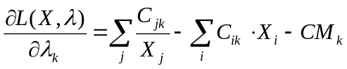 = primal constraint

Knowing the dual variable (λ_{i}),
we need to determine the primal variables X(λ_{i}).

Because the Lagrangien function is separable [Eq.(6)], the single dual problem with N design variables (N dimensions) is replaced by a series of N problems with a single dimension:

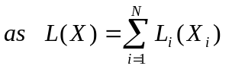 (As function with separable variables)

Each term of the L(X) minimisation [Eq.(6)] can be written in an explicit form:

MIN L_{i}(X_{i}) = A_{i} X_{i} + B_{i} / X_{i}

where A_{i} and B_{i} are defined as: 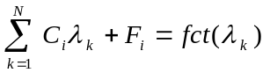

Note that the minimisation related to each X_{i} variable requires that ∂L_{i}/∂X_{i} = 0. Then,
COST MODEL

Optimum costs are calculated using the following cost and productivity data:

- Reference plate thickness: 20 mm

- k ratio = Unitary Labor Cost (Euro/m-h)/Material Cost (Euro/t)
k = 0.08 (USA)

- Unitary price of steel:
C1 = 0.57 Euro/kg , ΔC1 = -0.6% (if AE235)
C1 = 0.65 Euro/kg, ΔC1 = -0.6% (if AE355)

- Price of welding (materials only): C8 = 1.00 Euro/m , ΔC8 = 15%

- Manpower:
- plate: P10 = 0.5 m-h/m² , ΔP10 = 7%

- frames (assembling with plate) :
P4 = P5 = 1 m-h/m, ΔP4 = ΔP5 = 10%

- frames (if built on site):
P9 = 0.5 m-h/m, ΔP9 = 1%

MESH MODEL

The mesh model of the FSO unit includes:
- 22 stiffened panels with 9 design variables each;

- 198 design variables (9 x 22 panels);

- 48 equality constraints between design variables are used, e.g., to impose uniform frame spacing for the deck, bottom and central bulkhead in the center tanks and another one in the side ballast tanks.

- 198 geometrical constraints (9 x 22 panels). Since the web heights of longitudinal and transversal members are quite important, no geometrical constraints were selected for web slenderness. Web buckling stability and possibly their bracketing are then verified afterwards (post-optimization);

- 396 structural constraints (198 by load case):
- σ_{c} frame (web/plate junction – web/flange junction and flange),
σ_{c} stiffener (web/plate – web/flange and flange) and σ_{c} plate,
which should verified that σ_{c} ≤ s.σ_{o}
with s = 0.65 and σ_{o} = 355 N/mm²;
- local plate buckling: δ_{MIN} ≤ δ (with δ_{MIN} the minimum plate thickness to avoid buckling);
- ultimate strength of stiffened panel: σ/ σ_{ULT} ≤ s with s = 0.55 ;

- 2 constraints on the ultimate hull girder/box girder strength: M/M_{ULT} ≤ s (s = 0.55).

